STALite Implementation Details
Overview:
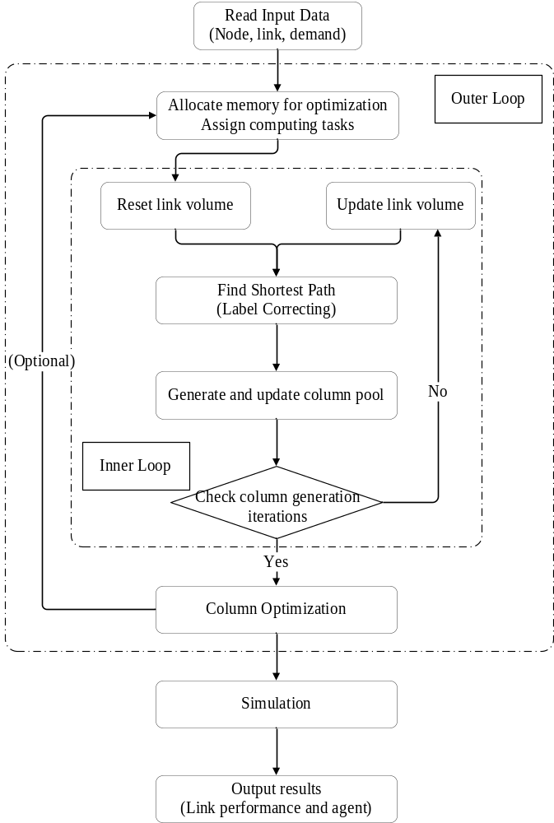

1.Classes Overview
Class | Description
class CCSVParser | Class for reading and writing .csv.
class CDemand_Period | Class for demand period /  Calculate starting(ending) time
class CAgent_type | Class for different demand agent type  (including agent’s VOT/PCE/CRU)
class CLinkType | Class for linktype
class CColumnPath | Class for node sequence/link sequence of a column.
class CAgentPath | Path sequence and statistics for each agent
class CColumnVector | Path sequence and statistics for each column
class CAgent_Column
class CAgent_Simu | Class for the agent in the simulation
class Assignment
class CVDF_Period | Calculate Volume Delay Function Period  (using BPR function)
class CLink | Class for roadlink
class CServiceArc | Class for service arc
class CNode | Class for node
class COZone | Class for origin zone
class CAGBMAgent
class NetworkForSP | Class for shortest path calculation
class VehicleScheduleNetworks
class CVSState | Class for vehicle scheduling states
class C_time_indexed_state_vector

Here, we explain some important classes briefly:
- Class Assignment
Class Assignment includes some basic globe parameters or variables for computing assignment, such as number of nodes, number of links, etc.
Initialize the demand array for each zone, agent type, demand period, and total demand array for each zone, period.

- Class NetworkForSP
void AllocateMemory(int number_of_nodes, int number_of_links)
Allocate memory and initialize the data for shortest path calculation.
void UpdateGeneralizedLinkCost()
Compute generalized link cost for each link, including travel_time_per_period, route_choice_cost and toll_cost / m_value_of_time.
void BuildNetwork(Assignment* p_assignment)
Build subnetwork in each workbench based on agent type and link type at iteration 0.

2.Read Input Data
- void g_ReadInputData(Assignment& assignment)
Read basic traffic network(node/link) data.

- void g_ReadDemandFileBasedOnDemandFileList(Assignment& assignment)
Read demand data.

3.Allocate Memory
- void g_assign_computing_tasks_to_memory_blocks(Assignment& assignment)
Prepare memory space for calculating the shortest path problem and assign each OD into corresponding workbench or thread.

4.Column Pool Generation
Find Shortest Path and Update Path Cost in each iteration
4.1 Reset and update link volume and cost
- void g_reset_link_volume_in_master_program_without_columns()
- void g_reset_link_volume_for_all_processors()
Only for User Equilibrium(UE) mode.
- void g_reset_and_update_link_volume_based_on_columns()
For System Optimization(SO) and User Equilibrium(UE) with resource constraints.

We use the BPR function to update travel time(TT):
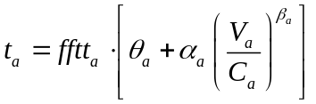
Where,
variables t_{a} (variable avg_travel_time in code) represents generalized travel cost (or time) on link a;
variable fftt_{a} (variable FFTT in code) is the free-flow travel time of link a;
variable Va or Xa (variable flow_volume_per_period or volume in code) represents flow volume on link a. Typically, V_{a} is used to cover composite flow volume in different applications, while Xa is used to denote nonnegative pure flow or fluid from the network flow modeling perspective.
C_{a} (variable capacity in code) represents the (ultimate) capacity of link a;
θ_{a}, α_{a}, β_{a} are the coefficients of VDF function for link a。

4.2 Label Correcting Algorithm
- float optimal_label_correcting(int processor_id, Assignment* p_assignment, int iteration_k, int o_node_index, int d_node_no, bool pure_travel_time_cost)
Label correcting algorithm with double queue implementation.
Generate the shortest path tree.
The pseudo-codes details of Label Correcting are as follows:
Algorithm：Deque Label Correcting Algorithm
begin
//Initialization
m_label_distance_array[from_node] = 0;
m_node_predecessor[from_node] = 0;
m_label_distance_array[j] = ∞ for each node j∈N-{from_node}；

SEList.pushback(from_node);
while SEList ≠ Φ do
begin
remove the first element on the left from SEList;
for each arc (i,j)∈A(i) do: //A(i) means the outgoing link set of node i
if m_label_distance_array[j] > m_label_distance_array[i] + link_cost(i,j) then:
begin
m_label_distance_array[j] = m_label_distance_array[i] + link_cost(i,j);
m_node_predecessor[j] = i;
if node j has not been in SEList earlier then add node j to the right end of SEList;
else add node j to the left end of SEList;
end;
end;
end;

- void BuildNetwork(Assignment* p_assignment)
Build the network for each O-D pair using the adjacency list.

4.3 Backtrace and generate column pool
- void NetworkForSP::backtrace_shortest_path_tree(Assignment& assignment, int iteration_number_outterloop, int o_node_index)
For each node, find it's shortest path tree and backtrace the SPP tree from destination to origin. Using node-sum method to append new path(like hash-table method).

4.4 Parallel Computing
In the allocate-memory process, we divide all OD pairs into 4 parts and realize parallel computing in different workbenches.
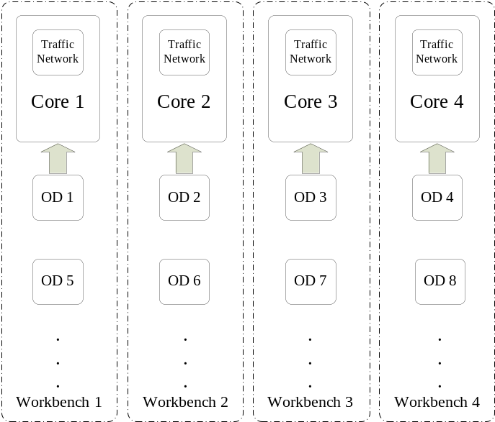
*Please refer to Guide into OpenMP: Easy multithreading programming for C++.
*Example:
#pragma omp parallel for
for (int ProcessID = 0; ProcessID < g_NetworkForSP_vector.size(); ProcessID++)
{
……
//Perform one to all shortest-path tree calculation in each processor
}

5.Column Pool Optimization
- void g_column_pool_optimization(Assignment& assignment, int column_updating_iterations)
Call g_update_gradient_cost_and_assigned_flow_in_column_pool for column_updating_iterations times

- void g_update_gradient_cost_and_assigned_flow_in_column_pool(Assignment& assignment, int inner_iteration_number)
Based on the newly calculated path volume and column pool, we update volume-based travel time and update volume-based resource balance using the reduced gradient method.
Step 1: Calculate the gradient cost for each column cost.
Step 2: Calculate gradient cost difference for each column cost.
Step 3: Update path flows
Step 3.1: Shift flow form non-shortest path to shortest path
Step 3.2: Consider the least-cost path, receive all volume shifted from the non-shortest path.
Step 4: Based on newly calculated path flows, update volume, and travel time.

6.Simulation
- void Assignment::STTrafficSimulation()
Given an optimization result, make the simulation, output the specific flow for each link and time, and output the departure time and arrival time for each agent.
For each simulation interval, active the agent, update the entrance queue, and exit queue.
- void Assignment::AllocateLinkMemory4Simulation()
Prepare memory space for the simulation process.

Step 1: Scan the different continuous paths in the column pool and generate a simulation agent for each column.
Step 2: Simulate traffic conditions at time t.
Step 2.1: Active simulation agents that are going to depart from the origin node.
Step 2.2: Push back the simulation agents into the corresponding entrance queue.
Step 2.3: Pop the simulation agents from the entrance queue and push it back into the exit queue, and update the total travel time at the same time.
Step 2.4: Check whether the agent has reached the destination node.
Step 3: Count the departure numbers and arrival numbers for each link at time t.
Step 4: Check link capacity and termination condition for each activated simulation agent.
Step 5: t = t + 1, and return step 2.

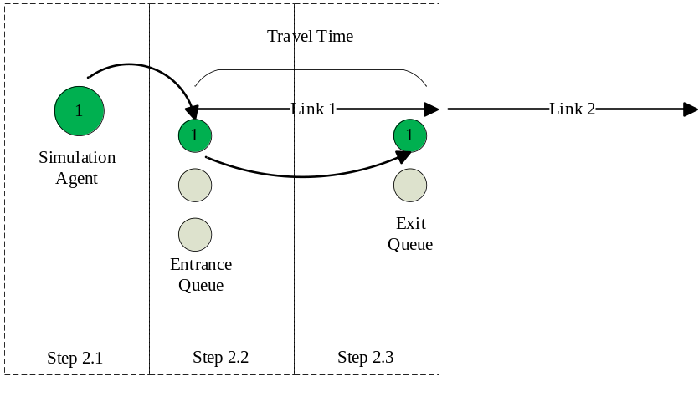
7.Output Results
- void g_output_simulation_result(Assignment& assignment)
Please refer to link_performance.csv and agent.csv(based on simulation)

